**Project Development Phase**

**Model Performance Test**

|  |  |
| --- | --- |
| Date | 10 November 2023 |
| Team ID | Team-593053 |
| Project Name | Predicting Mental Health Illness Of Working Professionals Using Machine Learning |
| Maximum Marks | 10 Marks |

|  |  |  |  |
| --- | --- | --- | --- |
| **S.No.** | **Parameter** | **Values** | **Screenshot** |
|  | Metrics | **Regression Model:** MAE-0.218666,  MSE-0.218666,  R2 score-0.125277    **Classification Model:** Confusion Matrix-  50.72222,  Accuray Score-  0.7813333 &  Classification Report-  0.80 | MAE,MSE,R2:    CONFUSION MATRIX:    ACCURACY SCORE:    CLASSIFICATION REPORT: |
|  | Tune the Model | Hyperparameter Tuning -  Validation Method - | HYPERPARAMETER TUNING:      VALIDATION METHOD: |

SCREENSHOTS:

MAE,MSE,R2:

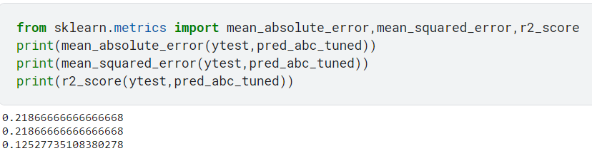

CONFUSION MATRIX:

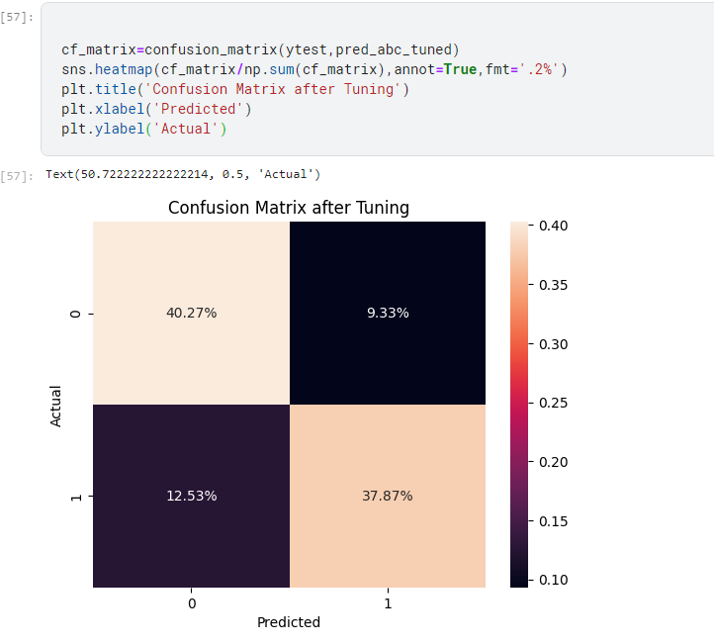

ACCURACY SCORE:

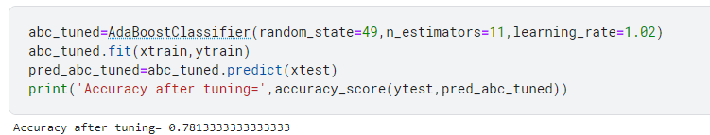

CLASSIFICATION REPORT:

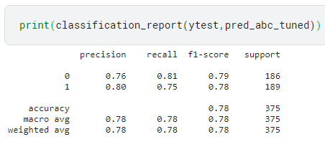

HYPERPARAMETER TUNING:



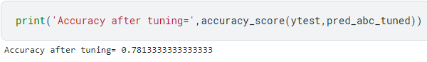

VALIDATION METHOD:

